**ASSIGNMENT -1**

**- By: Peetha Soma Tejaswi**

**Reg. no: 21bcb7133**

**Campus: VIT AP**

**1. Pie Chart**

Fields ->

Segment: product line

Size: gross income

Local filters: month -> 2

Properties ->

turn on display%

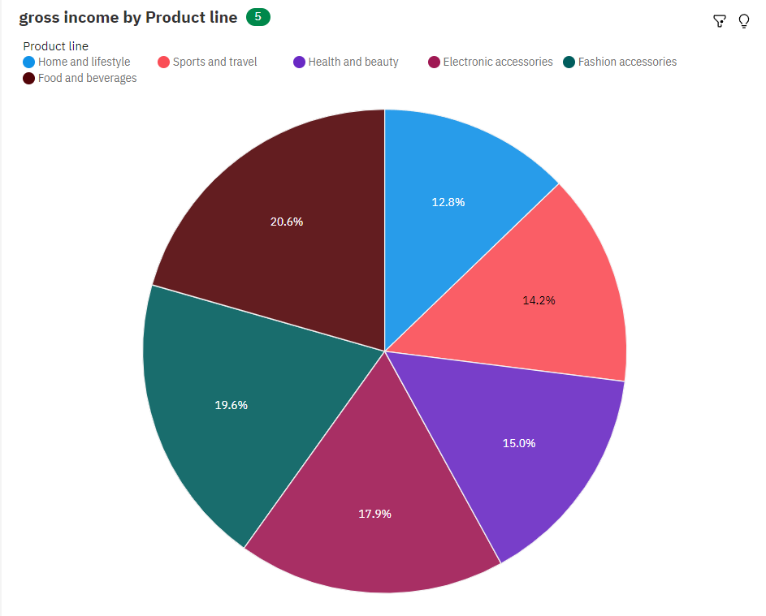

**2. Bar Chart**

Fields ->

Bars: gender

Length: rating

Color: customer type

Properties ->

Turn on show value labels

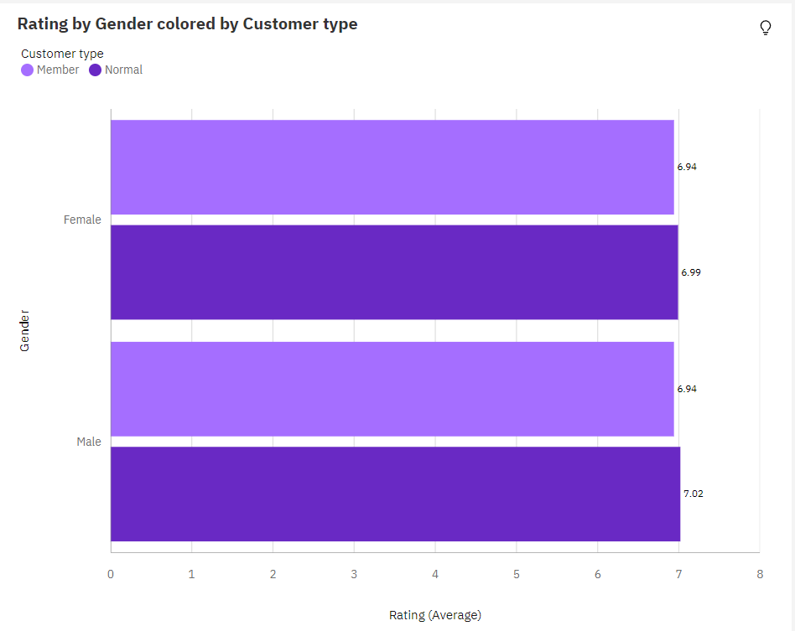

**3. Column Chart**

Fields ->

Bars: branch

Length: gross income

Color: product line

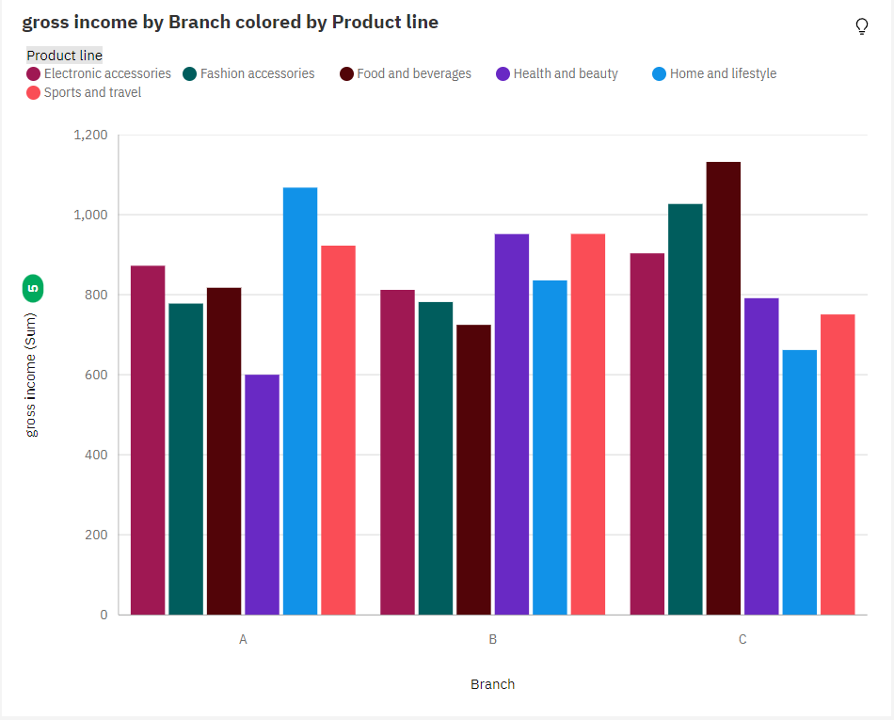

**4. Heat Map Chart**

Felids ->

Rows: branch

Columns: product line

Heat: gross income

Size: quantity

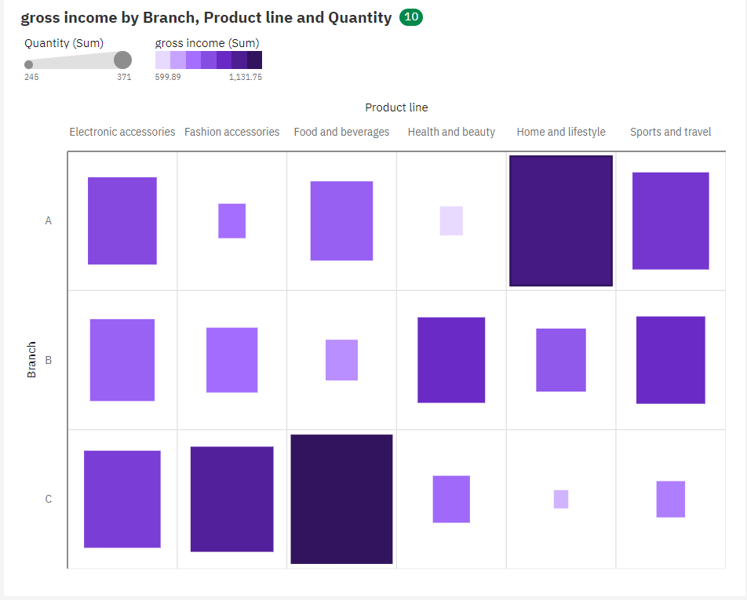

**5. Word Cloud Chart**

Fields ->

Words: product line

Size: gross margin percentage

Color: city

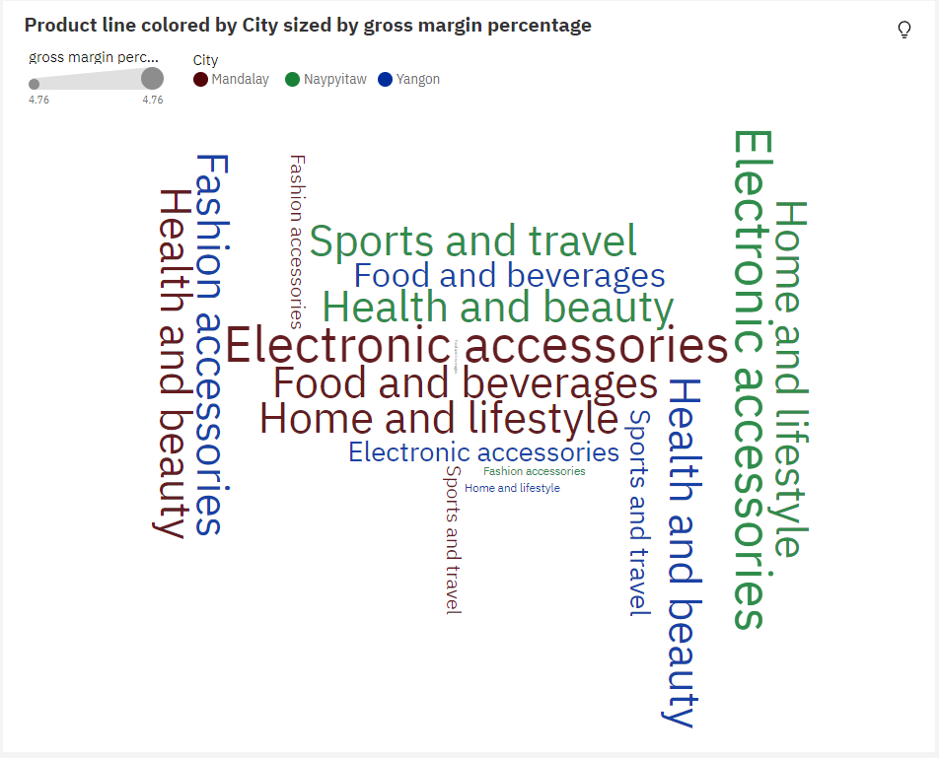

**6. Waterfall Chart**

Fields ->

X axis: product line

Y axis: gross margin percentage

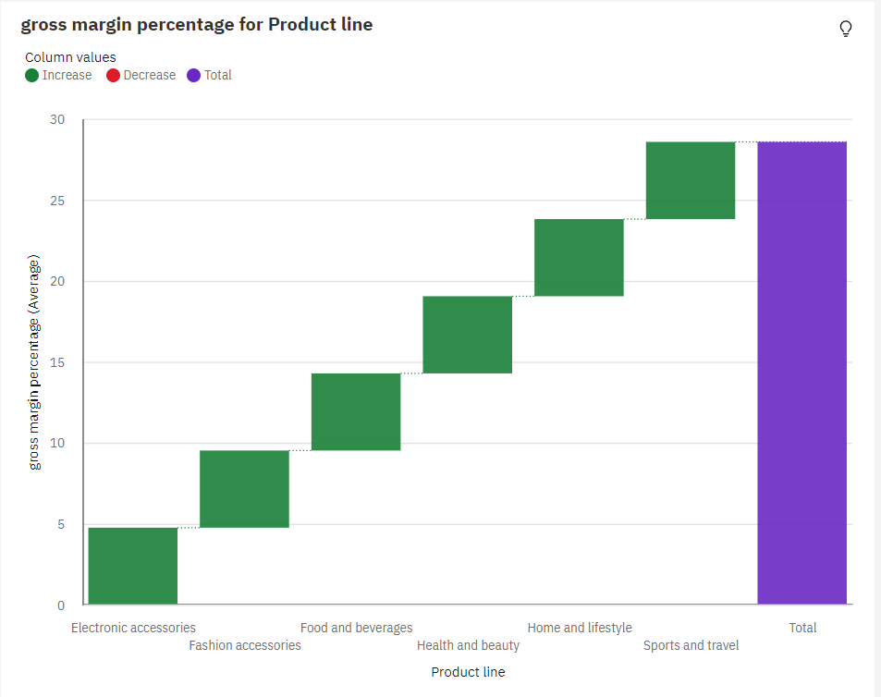

**7. Radial Chart**

Fields ->

Bars: month

Length: rating

Color: branch

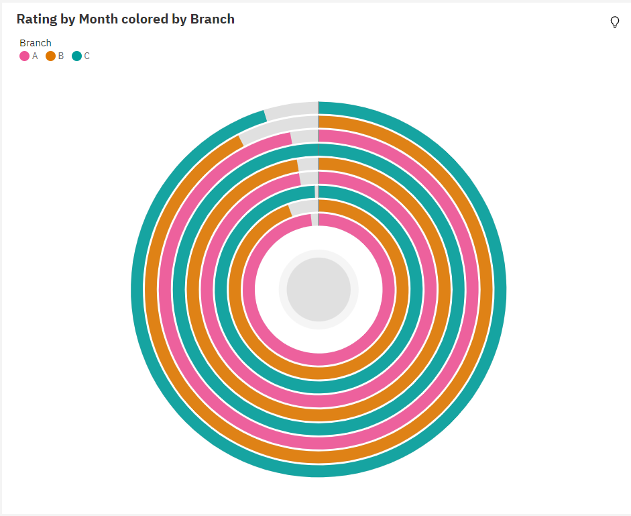

**8. Area Chart**

Felids ->

x-axis: month

y-axis: gross income

color: day of the week

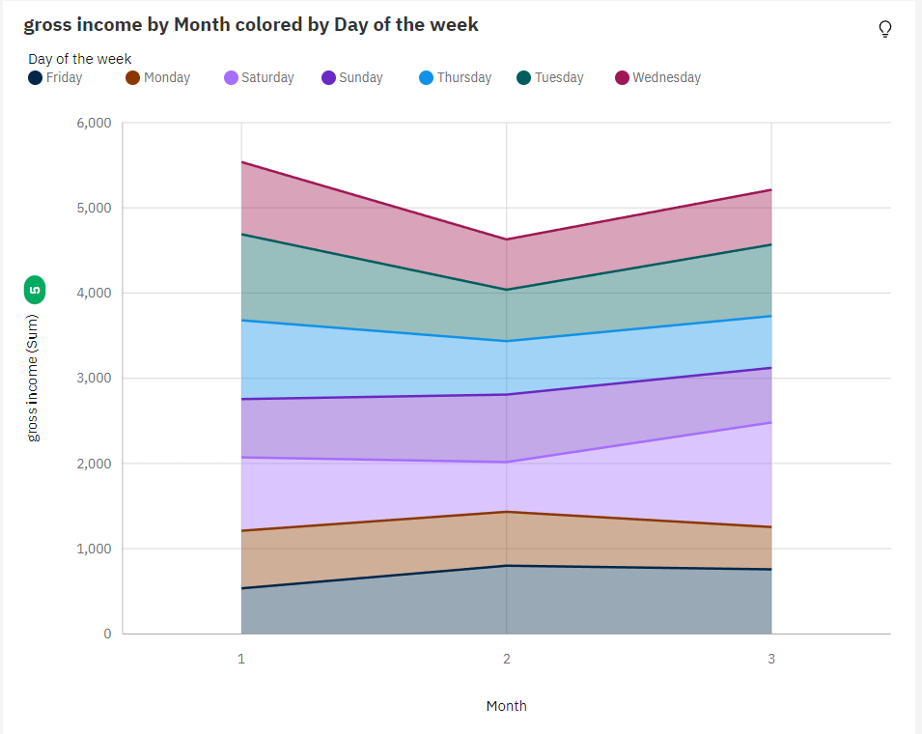

**9. Packed Bubble Chart**

Felids ->

Bubbles: city

Size: quantity

Color: product line

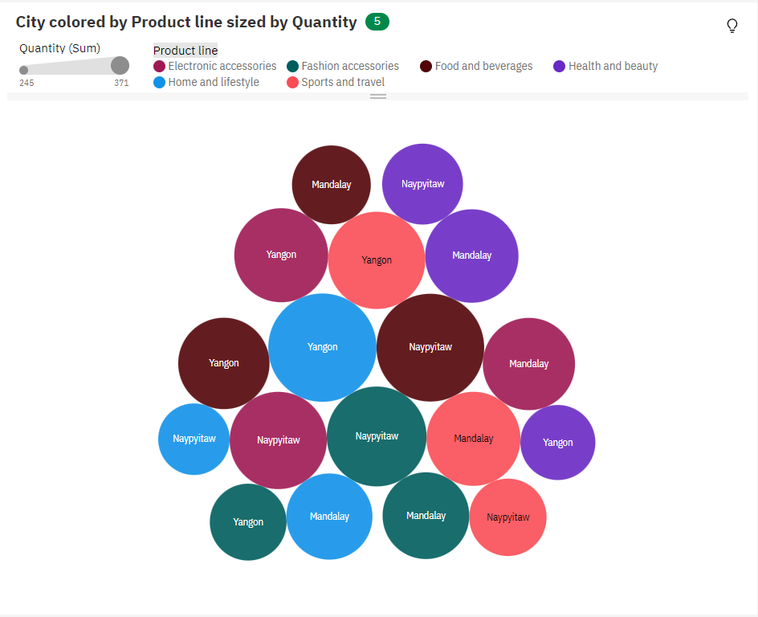

**10. Tree Map Chart**

Area hierarchy: product line and branch

Size: gross income

Heat: gross margin percentage

